Bullock Spirit Week 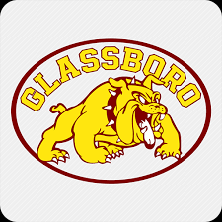
Monday Dec. 16th   | Tuesday Dec. 17th  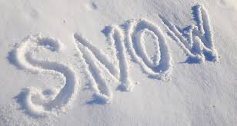 | Wednesday Dec. 18th   | Thursday Dec. 19th  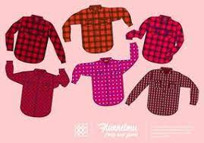 | Friday Dec. 20th  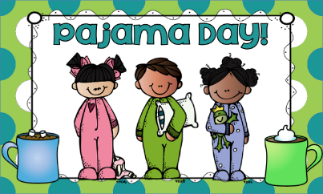
“Justice for all”  - Wear anything Marvel, DC, or super-hero related to celebrate CITRS character word of month-Justice. (No costumes allowed.)  *Board game day- we are always game to play fair-Bring in board games. | “Let it snow”  - Wear white or anything with snowflakes/snowmen to represent a winter wonderland. | “Brrr…it’s cold outside”  - Wear your favorite sweater. It can be ugly, festive, or fancy. | “Channel your flannel”  - Wear flannel or plaid attire. | “Wishing you a comfy and cozy winter break”  - Wear your comfy and cozy pajamas or sweatpants. (No slippers)  * Early dismissal day

